Iris Classification Using k-Nearest Neighbor Model
Allen Gao
University of Massachusetts Amherst
MIE622
Michael Prokle

The report will go on to analyze the Iris classification that uses the K-Nearest Neighbor algorithm. The purpose of the KNN was to classify the Iris flowers into three different species using four attributes. The Iris dataset was loaded from sklearn and analyzed using a 70/30 train-test split. The model used the training data to compare each test flower to similar flowers and predict its species. A three-dimensional scatter plot was also used to visualize the data, with different colors representing the three Iris species. As shown in Figure A2, the Iris species form three general clusters, although some flowers appear closer to another species cluster.
To build the nearest neighbor model, a function was created to take in the training set, training labels, one test instance, the value of k, and the distance method. In this model, k represents the number of closest training points used to classify a test point. The function goes through the training set and calculates the Euclidean distance between the test instance and each training observation. These distances are then sorted from smallest to largest, and the function selects the k closest observations as the nearest neighbors. After the nearest neighbors are found, they are passed into the vote function. The vote function counts the class labels of the nearest neighbors and predicts the Iris species with the most votes.
Once the functions were completed, the results were printed by iterating through each test sample and comparing the KNN classifier’s predicted species to the actual species label. For each test flower, the model found the nearest neighbors, used the vote function to predict the species, and then checked whether the prediction matched the correct class. This process was used to count the number of correct predictions and calculate the overall accuracy of the model.
The overall accuracy of the model was calculated by comparing the model’s predicted species to the actual species for all test samples. In the notebook, the number of test samples was set to 12. Out of the 12 test flowers, the KNN model correctly classified 11 flowers and incorrectly classified 1 flower, as shown in Figure A1. Therefore, the overall accuracy of the model would be 11 divided by 12, which equals 91.7%. This means that the model correctly classified most of the Iris flowers in the test set.
Based on Figure A1, the accuracy for type 0 of the Iris dataset was 100% because both type 0 test samples were correctly predicted by the model. In the output, type 0 appeared two times, and both times the result of the vote matched the actual label. Type 1’s accuracy was also 100% because all five type 1 test samples were correctly predicted. Type 2’s accuracy was 80% because the model correctly predicted 4 out of 5 type 2 test samples. The only incorrect prediction happened at index 8, where the model predicted Type 1, but the actual label was type 2. Therefore, type 0 had 100% accuracy, type 1 had 100% accuracy, and type 2 had 80% accuracy.
I would classify the KNN model as a good model because it correctly predicted 11 out of 12 Iris flowers, yielding an overall accuracy of 91.7% on the test set. The model performed especially well for type 0 and type 1, with both having 100% accuracy. Type 2 had a lower accuracy of 80% because one type 2 flower was misclassified as type 1. Based on these results, I would recommend the KNN model as a useful classification method for this dataset because it is simple to understand and performed well overall. However, I would also recommend testing the model with more test samples or multiple train-test splits to make sure the results are stable.

Appendix
Figure A1
KNN Prediction Results for Iris Test Samples
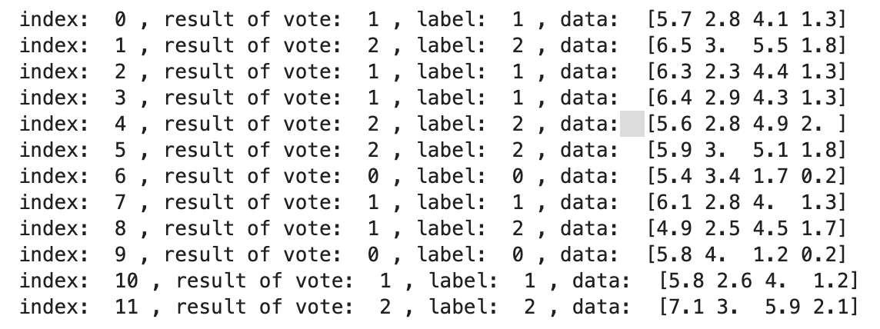
Note. Screenshot created by the author from the Python notebook output. The output shows the predicted labels made by the vote function, actual labels, and flower measurement data for each of the 12 test samples.
Figure A2
Three-Dimensional Scatter plot of Iris species
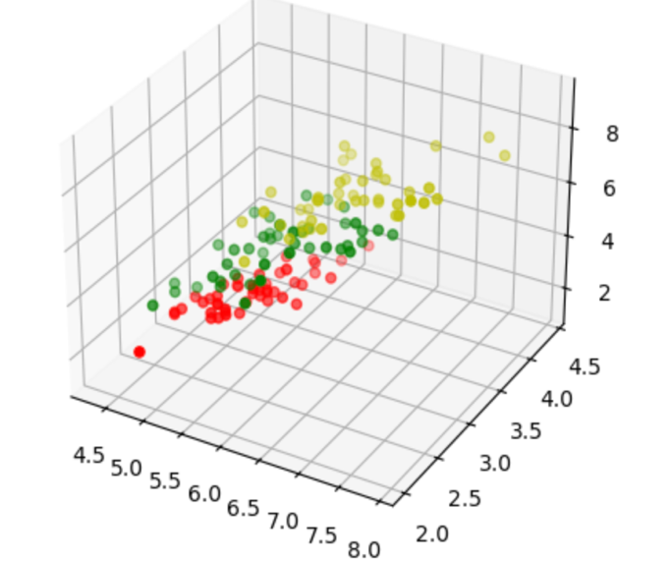
Note. Screenshot created by the author from the Python notebook output. The different colors represent the three Iris species, and the plot shows how the flowers are grouped based on their measurements.

